**Bowling Pins Project**

**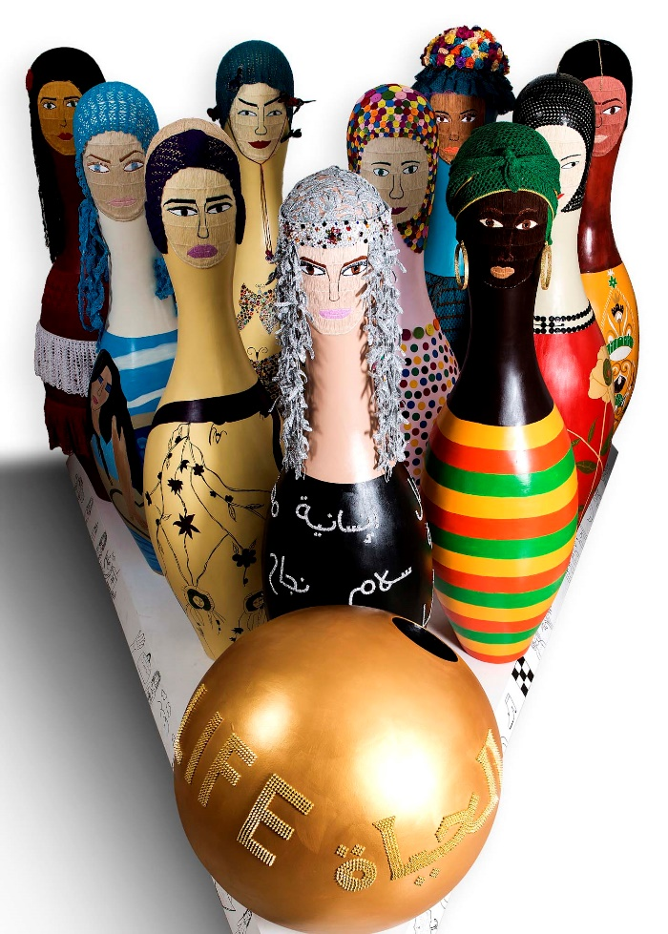*“No matter how much you hold me down. I’ll stand up again….”***

An artwork that represents victims of human trafficking and their ability to survive, restore confidence, dignity and emotional wellbeing no matter what they've been through and what they suffered when they were trafficked.

**10 / 3D Human size sculpture bowling pins, base and a ball.**

A story of an artwork done by over twenty (women and children) survivors of human trafficking. Survivors from different nationalities, stories, background, age, agony and hope for a better life. They all came together under one roof at Ewaa shelters.

The art work tells survivors that you are not alone, we are here to stand strong with you to help you get back on your feet and face what you've been through. It shows a mix of nationalities, dressed in national costume. All of them women standing powerful and strong like ten bowling pins in the face of adversity. The ball is golden with the word “life” written across it in Arabic and English. The words are made of golden spikes making the ball more dangerous than what it seems.

As part of Ewaa shelters initiatives to rehabilitate victims of human trafficking, ***art therapy*** has always been a major tool in the process of healing the survivors. Most have never touched a paintbrush before, let alone entered a gallery so the experience is alien to them but had a powerful effect in giving them a voice. They often start off shy, reluctant and completely unsure of what to do. Gradually they overcome this fear as their ability to express themselves improves.

It took months of planning, sketching, painting, beading and embroidery. Each survivor added her own touch of art.

A journey of days filled with hard work, joy, fear of failure and finally a great feeling of achievement and victory.. Their excitement and joy to see their artwork exhibited in the gallery was so overwhelming.

This art work was the idea of an artist called **Jennifer Simon** (an artisit) who have been working with the survivors at Ewaa Shelters since 2012 in cooperation with **Abu Dhabi Music and Arts Foundation** (www.admaf.org/en).